EXERCISE 5: TRIGGERS
Scenario 1: Automatically Update LastModified Date
Question:
Write a trigger UpdateCustomerLastModified that automatically updates the LastModified column whenever a customer's record is updated.
Code
CREATE OR REPLACE TRIGGER UpdateCustomerLastModified
BEFORE UPDATE ON Customers
FOR EACH ROW
BEGIN
:NEW.LastModified := SYSDATE;
END;
/
Execution
UPDATE Customers
SET Balance = Balance + 1000
WHERE CustomerID = 1;

SELECT CustomerID,
Name,
Balance,
LastModified
FROM Customers
WHERE CustomerID = 1;
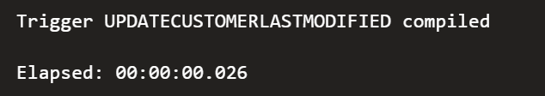
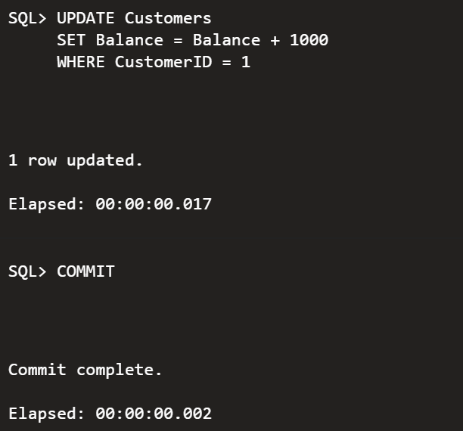
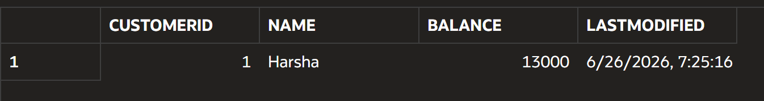

Scenario 2: Log New Transactions
Question:
Create a trigger LogTransaction that records every new transaction into the AuditLog table whenever a transaction is inserted.
Create AuditLog Table
CREATE TABLE AuditLog(
LogID NUMBER GENERATED BY DEFAULT AS IDENTITY,
TransactionID NUMBER,
LogDate DATE
);
Trigger Code
CREATE OR REPLACE TRIGGER LogTransaction
AFTER INSERT ON Transactions
FOR EACH ROW
BEGIN
INSERT INTO AuditLog(
TransactionID,
LogDate
)
VALUES(
:NEW.TransactionID,
SYSDATE
);
END;
/
Execution
INSERT INTO Transactions
VALUES(
7,
1,
SYSDATE,
500,
'Deposit'
);

SELECT *
FROM AuditLog;

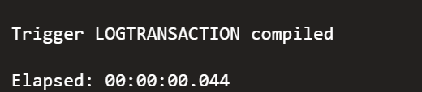
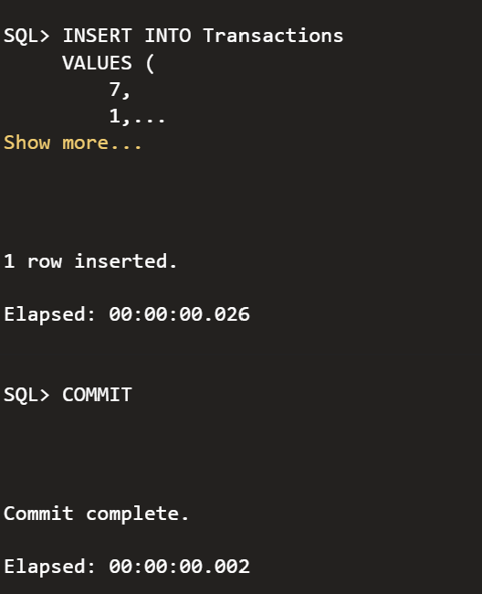
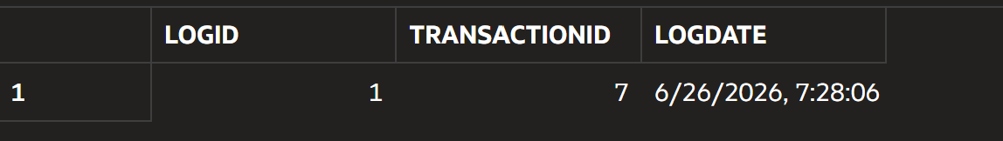

Scenario 3: Validate Transaction Rules
Question:
Write a trigger CheckTransactionRules that validates transaction rules before inserting a transaction. Deposits must have a positive amount, and withdrawals must not exceed the available account balance.
Code
CREATE OR REPLACE TRIGGER CheckTransactionRules
BEFORE INSERT ON Transactions
FOR EACH ROW
DECLARE
v_balance NUMBER;
BEGIN

IF :NEW.TransactionType = 'Deposit'
AND :NEW.Amount <= 0 THEN

RAISE_APPLICATION_ERROR(
-20001,
'Deposit amount must be greater than zero.'
);

END IF;

IF :NEW.TransactionType = 'Withdrawal' THEN

SELECT Balance
INTO v_balance
FROM Accounts
WHERE AccountID = :NEW.AccountID;

IF :NEW.Amount > v_balance THEN

RAISE_APPLICATION_ERROR(
-20002,
'Insufficient account balance.'
);

END IF;

END IF;

END;
/
Execution
INSERT INTO Transactions
VALUES(
8,
1,
SYSDATE,
50000,
'Withdrawal'
);

